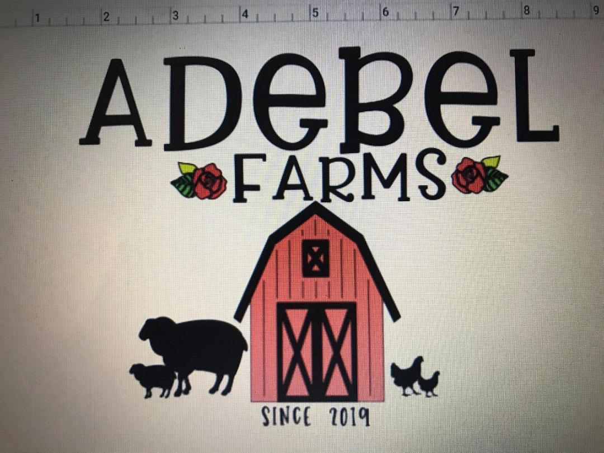
Puppy Application

Full Name

Address
Email
Phone:
Number of Adults in Household
Number of Children in Household
Age of Youngest Child
Is anyone in your family allergic to pets?
- No
- Yes
- Don't Know
Number of pets living with you?
If you have other pets, what kind, age and temperament, are they spayed and neutered?*

What do you like about Great Danes? Why do you think the breed is right for your family?When are you looking to add a Great Dane to your family?
Preferred Sex
- Any
- Male
- Female

Preferred Colors
Any
- Harlequin
- Mantle
- Merle
- Black with White
What Activities are you planning to do with your Dane?
Companion
- Rally
- Agility
- Barn Hunt
- Conformation Showing
- Obedience
- Protection
- Therapy Work
- Tracking
- Breeding
Where will your new Dane spend most of his/her time?
Indoor/Outdoor Kennel Outdoor Kennel
Outside in the yard Inside loose or in crate Inside in segregated area
Is your yard fenced?
- Yes, partially
- Yes, fully
Please describe the height, fencing material, age and condition of your fence.

Do you own or rent your home?
- Own
- Rent
If you rent, is your landlord ok with having a Dane on the property?
Have you owned a Dane previously?
No
- Yes
- Yes, currently
Are you aware of the costs that come with owning a Dane?

Are you willing to go to obedience training with your Dane?

Danes need special food to keep their joints and bodies healthy. Are you willing to purchase this food that may be priced more than regular dog food?

How many hours a day would you leave your Dane alone?
1-3 Hours
3-6 Hours
6-8 Hours
8-10 Hours
Over 10 Hours
Where will the dog be when no one is at home?
Where will the dog sleep at night? Will they sleep on the bed with you, in your room, on a dog bed, crated, confined to some other room in the house, in the garage, yard or kennel?

Are you willing to follow the Health Guidelines and advice supplied by Adebel Farms Animal Breeding regarding shots, exercise,

Please provide two references, one being your vet or someone you've purchased a dog from and include their phone numbers.
Anything else you would like to tell or ask us that may be pertinent to getting a great dane puppy? Any upcoming changes to any of the above in the near future?

